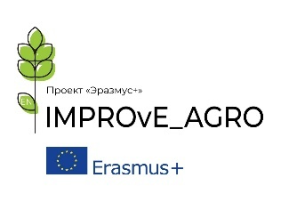
Project Erasmus+ + № 561775-EPP-1-2015-1-DE-EPPKA2-CBHE-JPInternationalizing Master Programmes in Agriculture via English Medium Instruction(IMPROvE _AGRO)
______________________________________________________________________________
«Интернационализация магистерских программ в сфере сельского хозяйства через преподавание на английском языке (IMPROvE _AGRO)»

Curriculum Development for English Medium Instruction
On-line course
Date: 14th – 20th October 2020
Time: 10-12 Central European Time
Facilitators:
Matthias Hutz, Freiburg l University of Education, Germany
Sue Garton, Aston University, UK
Dr. Karpouzos Dimitrios, Aristotle University of Thessaloniki
Prof. Dr. Elpida Kolokytha, Aristotle University of Thessaloniki

Introduction:
This course is for lecturers/professors in Agriculture, Forestry and related disciplines who will be updating their curricula as part of the IMPROvE_Agro project. It aims to introduce them to both the theoretical principles and the practical application of curriculum design according to European standards as well as to the principles of blended learning to support English medium instruction. The idea behind the IMPROvE_AGRO project is to introduce EMI into a number of modules in Agriculture, Forestry and related disciplines at Master’s level. The course aims to support Agriculture and Forestry lecturers as adapt their curricula and make the transition to teaching through English.
At the end of the course, participants will:
- understand the principles of curriculum development according to European standards;
- analyse the practical aspects and pedagogical approaches to implementing English Medium instruction;
- evaluate the relevance of experiences in curriculum design ofEuropean partners to their own contexts;
- acquire the tools to introduce a model blended learning/flipped classrooms suitable for their local contexts.

Programme

Date | Topic | Partner
WednesdayOctober 14th  10-12 CET | General Introduction to the project and to the programme | Freiburg l University of Education /Tyumen State University
ThursdayOctober 15th  10-12 CET | Principles of Curriculum Development and Quality control | Aston University
Friday October 16th  10-12 (CET) | Blended Learning/Flipped Classrooms | Freiburg l University of Education /Aston University
MondayOctober 19th  9-12 (CET)  Please note this workshop is 3 hours and starts a 9am CET | Curriculum design based on Bologna principles–  the Aristotle University of Thessaloniki experience. | Aristotle University of Thessaloniki
TuesdayOctober 20th  10-12 (CET) | Open session (Q&A Discussion of modules, challenges etc.) | All partners

NB all times given are Central European Time

